Truncated Prisms and Antiprisms

Definition
# Source: AI Source: Provided by: [Data Path: Persons Table -> ID Column: 1, Name_En Column: Motasem Essam] -> From: [ChatGPT] on [7/25/2026]
Truncated Prisms and Antiprisms are three-dimensional polyhedra formed by cutting off portions of original prisms or antiprisms using planes.
The truncation process modifies the original polygonal faces, edges, and vertices while creating new polygonal faces called Truncation Faces.
Truncation can be applied to different types of prisms and antiprisms.

Types of Truncated Prisms and Antiprisms
# Source: AI Source: Provided by: [Data Path: Persons Table -> ID Column: 1, Name_En Column: Motasem Essam] -> From: [ChatGPT] on [7/25/2026]
The following examples are listed in your source document:
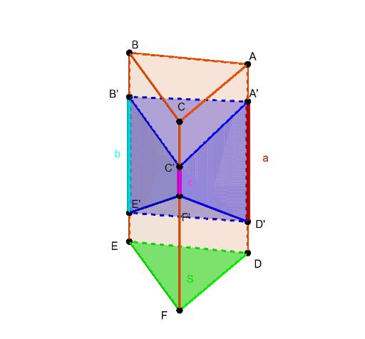

Truncated Triangular Prism
# Source: AI Source: Provided by: [Data Path: Persons Table -> ID Column: 1, Name_En Column: Motasem Essam] -> From: [ChatGPT] on [7/25/2026]
Formed by cutting portions of a triangular prism, modifying its triangular bases and rectangular lateral faces.
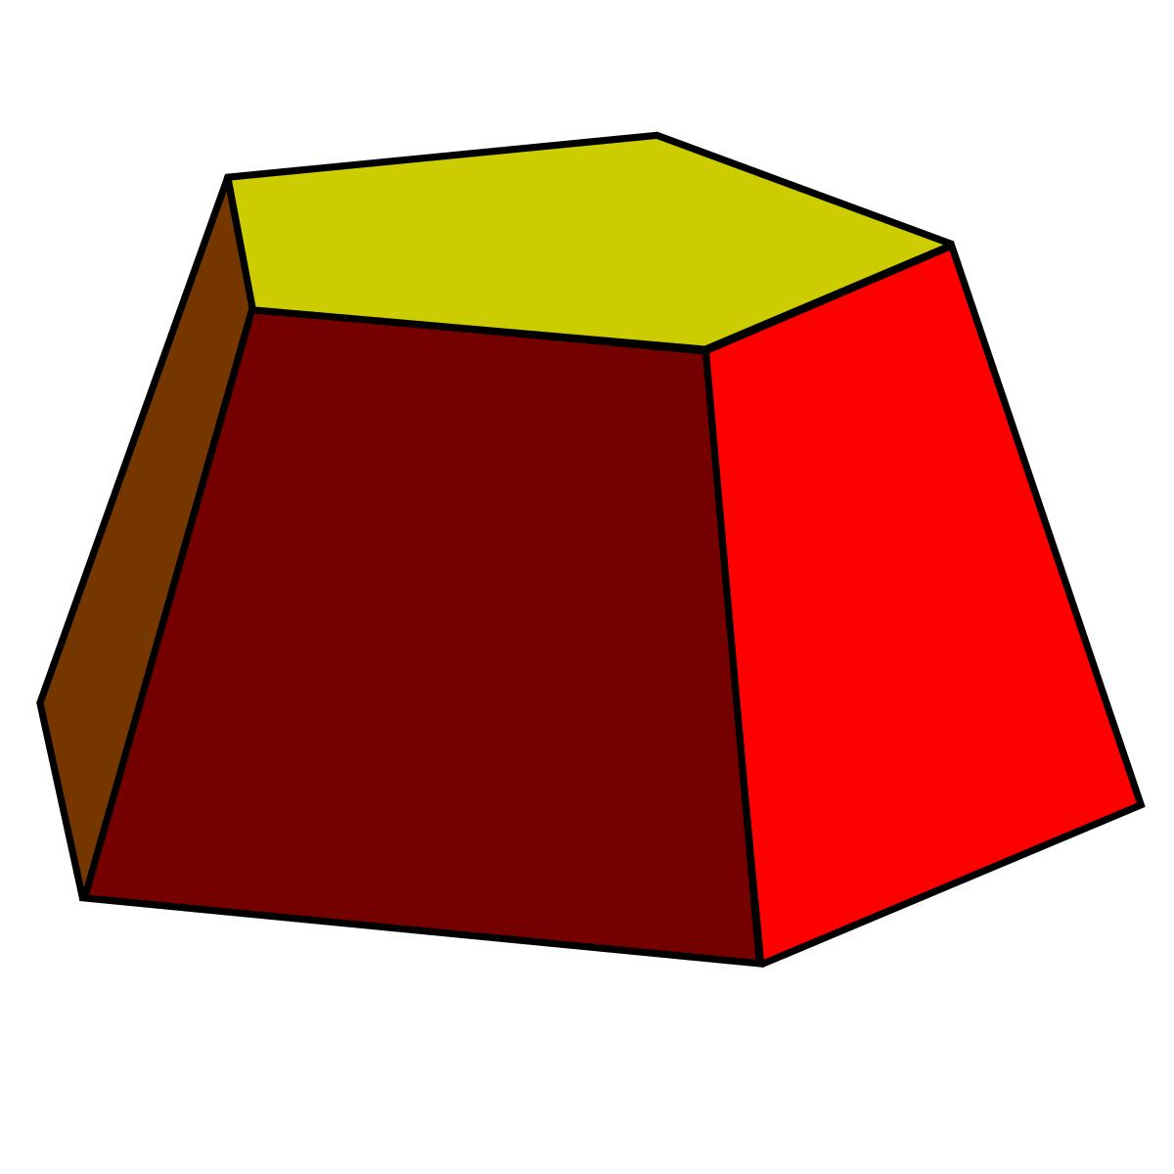

Truncated Pentagonal Prism
# Source: AI Source: Provided by: [Data Path: Persons Table -> ID Column: 1, Name_En Column: Motasem Essam] -> From: [ChatGPT] on [7/25/2026]
Formed by cutting portions of a pentagonal prism, modifying its pentagonal bases and lateral faces.
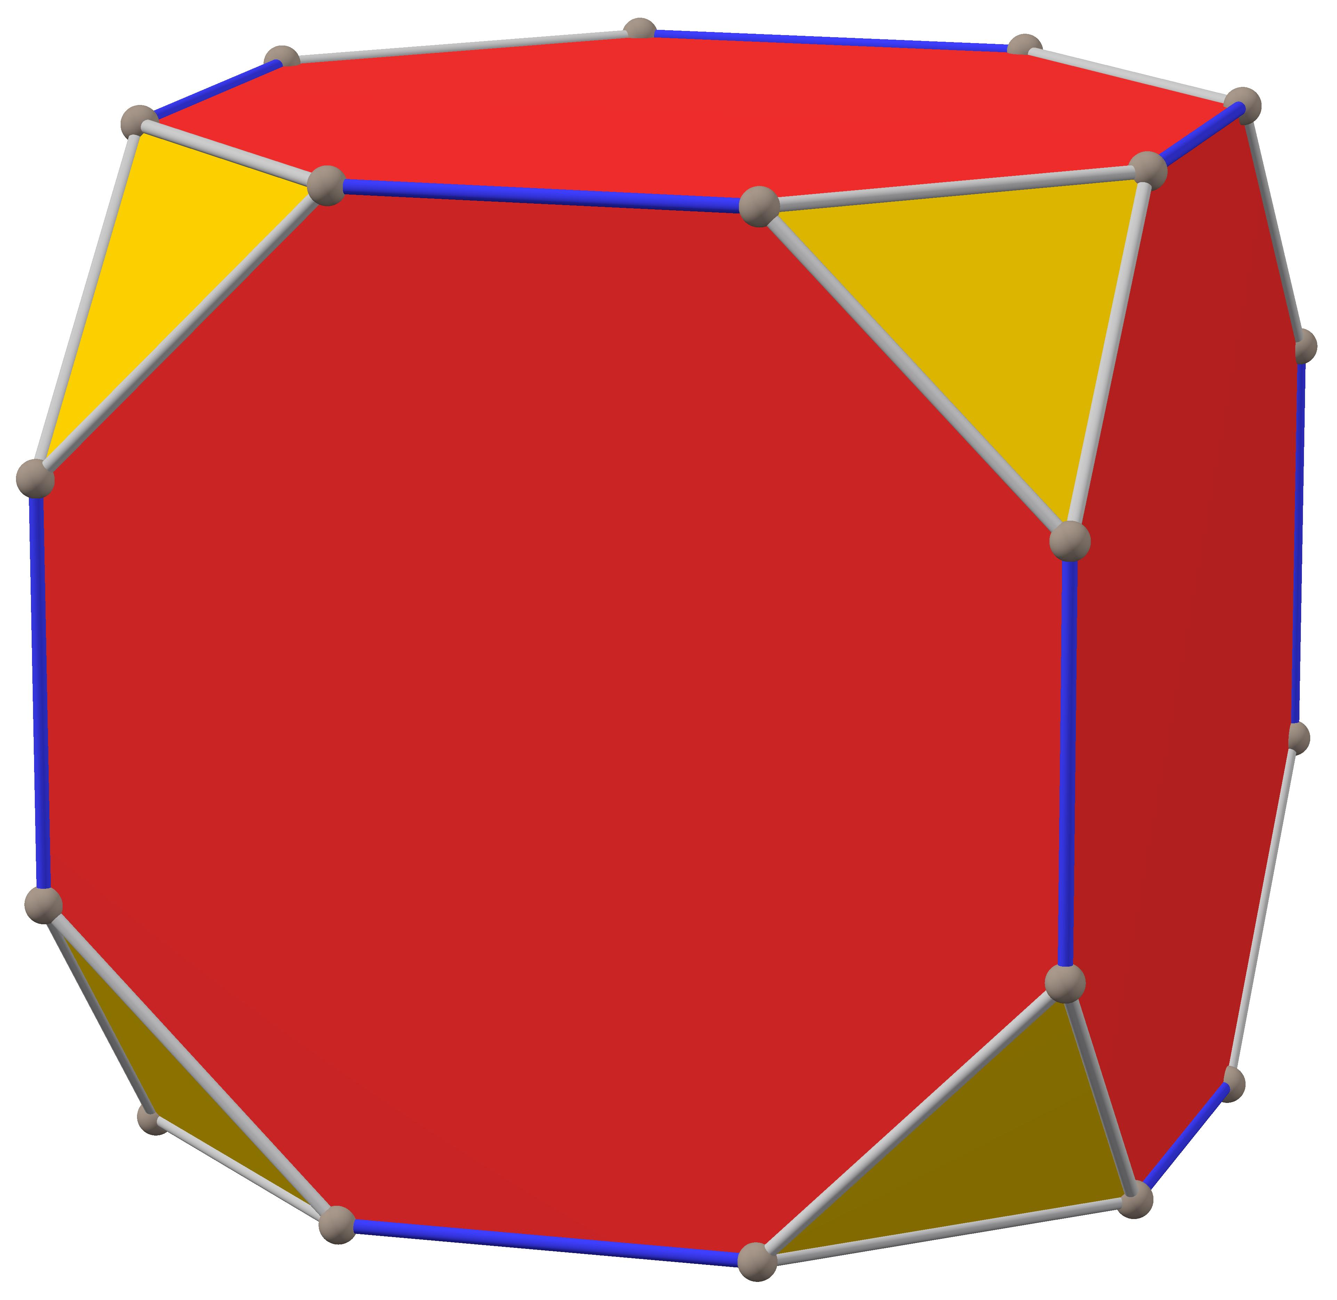

Truncated Hexagonal Prism
# Source: AI Source: Provided by: [Data Path: Persons Table -> ID Column: 1, Name_En Column: Motasem Essam] -> From: [ChatGPT] on [7/25/2026]
Formed by cutting portions of a hexagonal prism, modifying its hexagonal bases and lateral faces.
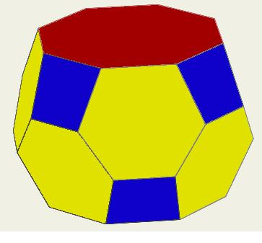

Truncated Antiprism
# Source: AI Source: Provided by: [Data Path: Persons Table -> ID Column: 1, Name_En Column: Motasem Essam] -> From: [ChatGPT] on [7/25/2026]
Formed by cutting portions of an antiprism, modifying its polygonal bases and triangular lateral faces.

Geometric Characteristics
# Source: AI Source: Provided by: [Data Path: Persons Table -> ID Column: 1, Name_En Column: Motasem Essam] -> From: [ChatGPT] on [7/25/2026]
Truncated prisms and antiprisms generally have the following characteristics:
- Original Faces: Polygonal faces inherited from the original prism or antiprism.
- Truncation Faces: New polygonal faces created by cutting.
- Modified Edges: Original edges shortened or modified by truncation.
- New Edges: Edges formed by the intersections of cutting planes with the original faces.
- Modified Vertices: Original vertices may be removed or replaced by new vertices.

Key Points
# Source: AI Source: Provided by: [Data Path: Persons Table -> ID Column: 1, Name_En Column: Motasem Essam] -> From: [ChatGPT] on [7/25/2026]
- They originate from prisms and antiprisms.
- They are formed through planar cutting operations.
- Their resulting face arrangements depend on the original solid and the truncation method.
- Different polygonal bases produce different types of truncated prisms.
- Truncated antiprisms retain geometric features derived from their original antiprism structures.

Conclusion
# Source: AI Source: Provided by: [Data Path: Persons Table -> ID Column: 1, Name_En Column: Motasem Essam] -> From: [ChatGPT] on [7/25/2026]
Truncated Prisms and Antiprisms are modified polyhedra formed by removing portions of original prisms or antiprisms through planar cuts. They represent a category of truncated polyhedra whose resulting structures depend on the original polygonal base and the applied truncation method.

